What Can Be the Maximum Between Two Consecutive Prime Numbers?
It is known that there are large gaps between large prime numbers. It has been proven that these gaps can be reached when desired. For example, between two consecutive prime numbers, 1000 numbers with no prime numbers can be found; Again, if desired, prime numbers with 1000000 spaces can be found. In this case, the question arises of how much space should be maximum between two consecutive prime numbers. In this situation, the Russian mathematician Tschebyscheff proved the inequality of 2$p_{n}$>$p_{n+1}$ for the prime number $p_{n+1}$ after${ p}_{n}$. By developing this proof, inequalities can be obtained which are later obtained closer.

This inequality creates a huge difference in consecutive prime numbers in the list of about 1000 000 prime numbers that I use, which can be considered relatively small.
I've always wondered about the maximum difference that can occur between two consecutive prime numbers. While dealing with inequalities, I started the following study by investigating what the result might be when a rule valid for all series in general is applied to prime numbers.
If the sum of any prime number up to itself is written:

Σ$p_{n+1}$= 2 + 3 + 5 +......+ $p_{n}$+ $p_{n+1}$
Σ$p_{n}$= 2 + 3 + 5 +......+ $p_{n-1}$+ $p_{n}$
Σ$p_{n-1}$= 2 + 3 + 5 +......+ $p_{n-2}$+ $p_{n-1}$
Σ$p_{n+1}$= Σ$p_{n}$+ $p_{n+1}$
Σ$p_{n-1}$= Σ$p_{n}$- $p_{n}$
Let's multiply these equations side by side:
Σ$p_{n+1}$ . Σ$p_{n-1}$ = (Σ$p_{n}$+ $p_{n+1}$) (Σ$p_{n}$- $p_{n}$) This equality is an expected result in various series.
The right-hand side of the above equation is arranged:
Σ$p_{n+1}$ . Σ$p_{n-1}$= $(Σ{p_{n})}^{2}$+ Σ$p_{n}$ ($p_{n+1}$- $p_{n}$) - $p_{n+1}$. $p_{n}$
$p_{n+1}$- $p_{n}$= k veya $p_{n}=p_{n+1}-k$ is placed in the following equation and
Σ$p_{n+1}$ . Σ$p_{n-1}$= $(Σ{p_{n})}^{2}$+ Σ$p_{n}$ ($p_{n+1}$- $p_{n}$) - $p_{n+1}$. $p_{n}$
Σ$p_{n+1}$ . Σ$p_{n-1}$= $(Σ{p_{n})}^{2}$ + kΣ$p_{n}$ - ${p^{ 2}}_{{n+1}^{}}$+ k $p_{n+1}$ ve $p_{n+1}$ If arranged according to:
${p^{ 2}}_{{n+1}^{}}$- k $p_{n+1}$ - $(Σ{p_{n})}^{2}$- kΣ$p_{n}$ + Σ$p_{n+1}$. Σ$p_{n-1}$= 0
Δ = $k^{2}+$ 4$(Σ{p_{n})}^{2}$ + 4kΣ$p_{n}$- 4kΣ$p_{n+1}.$ Σ$p_{n-1}$
Δ = (2Σ$p_{n}$+$k)^{2}$- 4kΣ$p_{n+1}.$ Σ$p_{n}$ Δ>0 k = $p_{n+1}$- $p_{n}$
2Σ$p_{n}$ + $p_{n+1}$- $p_{n}$ > 2$\sqrt{Σp_{n+1}. Σp_{n-1}}$
2Σ$p_{n}$ - $p_{n}$ > 2$\sqrt{Σp_{n+1}. Σp_{n-1}}$ - $p_{n+1}$ (1)
(2Σ$p_{n}$ - $p_{n}$) - 2$\sqrt{Σp_{n+1}. Σp_{n-1}}$ + $p_{n+1}$ = h (2)

If the following changes are made for ease of writing:
a = Σ$p_{n+1}$ ; b = Σ$p_{n}$ ; c = Σ$p_{n-1}$
$q_{1}=p_{n} ;$ $q_{2}=p_{n+1} ;$ $p_{n+1}$ - $p_{n}$ = k

With the new notation:
h = 2b - $q_{1}$ - 2$\sqrt{ac}$ + $q_{2}$ $q_{1}$ = b - c $q_{2}$= a - b
h = 2b - b + c - 2$\sqrt{ac}$ + a - b
h = a + c - 2$\sqrt{ac}$
h = ($\sqrt{a}-\sqrt{c})^{2}$ (3)
$\sqrt{h}=\sqrt{a}$ $-$ $\sqrt{c}$ (4)

If the closest value to h is found:

$\sqrt{a}$ = $\sqrt{c} +\sqrt{h}$ Although it is not our purpose using the expression (5) Σpn+1
can be calculated at that proximity.

$λ_{h}$= $\frac{h}{q_{2}}$ ; $λ_{b}$= $\frac{q_{1}}{b}$ ; $λ_{c}$= $\frac{q_{1}}{c}$ ; $λ_{a}$= $\sqrt{\frac{h}{a}}$

The (λ) values are shown in the LIST for various prime numbers. In the list, $λ_{h}$ and $λ_{b}$ values seem very close to each other.

$\frac{h}{q_{2}}$≅ $\frac{q_{1}}{b}$ h.b = $q_{1}$. $q_{2}$ ( $q_{1}$= b - c ; $q_{2}$ = a - b) ⇒ if placed

($b^{2}-2ac)^{2}= 0$ a = $\frac{b^{2}}{c}$ or $q_{2}$= $q_{1}$.$\frac{b}{c}$
These are approximate values. The superscript notations a', b', c', q1', q2'……etc. will be used where necessary in the future to distinguish them from their real values.

(2) Equation:
h = 2b - $q_{1}$- 2$\sqrt{ac}$ + $q_{2}$ ve h = $q_{2}$. $λ_{h}$
2b - $q_{1}$- 2$\sqrt{ac}$ + $q_{2}$ = $q_{2}$. $λ_{h}$
a = b + $q_{2}$ ; c = b - $q_{1}$the links are put in place, both sides are squared:
${q_{2}}^{2}$(1 - $λ_{h})^{2}$+ 2$q_{2}$ (1- $λ_{h}$) (2b- $q_{1}$) + (2b- $q_{1})^{2}$= 4 (b + $q_{2}$) (b - $q_{1}$)
${q_{2}}^{2}$(1 - $λ_{h})^{2}$+ 2$q_{2}$ ($q_{1}$- 2b$λ_{h}$ + $λ_{h}q_{1}$) + ${q_{1}}^{2}$ = 0
${q_{2}}^{2}$(1 - $λ_{h})^{2}$ - 2$q_{2}$ ($λ_{h}$c + $λ_{h}$b -${ q}_{1}$) + (b-c$)^{2}$= 0 (6)

$q_{2}$ =$\frac{c λ_{h} + b λ_{h} - q_{1}± 2\sqrt{c λ_{h} ( b λ_{h} - q_{1})}}{(1 - λ_{h})^{2}}$

$q_{2}$ = [ $\frac{\sqrt{c λ_{h}} ± \sqrt{b λ_{h} - q_{1}}}{1 - λ_{h}}$ ]² (7)
If attention is paid to the second black root:
b $λ_{h}$> $q_{1}$ ; $λ_{h}$>$\frac{q_{1}}{b}$ or $λ_{h}$>$λ_{b}$.
b $λ_{h}$ - $q_{1}$ = 0 if $λ_{h}$ = $λ_{b}$ ve $q_{2}'$ = $q_{1}$.$\frac{b}{c}$
Here $q_{2}'$ is taken as an approximation. (The actual value is $q_{2}$.)
If equation (2) is arranged according to $λ_{h}$:
$λ_{h}$ = $\frac{(\sqrt{a} - \sqrt{c}{ )}^{2}}{q_{2}}$ is found.
If this function is graphed:

$λ_{h}$= $\frac{a+c -2\sqrt{ac}}{q_{2}}$ $a=b+$ $q_{2}$
$λ_{h}$= $\frac{b+c+q_{2} -2\sqrt{c(b+q_{2})}}{q_{2}}$ Differentiation:

$λ_{h}'$ = [(1 - $\frac{2\sqrt{c}}{2\sqrt{b+q_{2}}}$) $q_{2}$ - (b+c+$q_{2}$) + 2 $\sqrt{c(b+q_{2})}$ ]: ${q_{2}}^{2}$
$λ_{h}'$= ${\frac{q_{2}\sqrt{}c - (b+c)\sqrt{b+q_{2}} + 2b\sqrt{c}}{{q_{2}}^{2}\sqrt{b+q_{2}}}}^{}$ $λ_{h}'$=by making 0;
$\sqrt{c}$ (2b + $q_{2}$) = (b + c) $\sqrt{b+q_{2}}$
c${q_{2}}^{2}$- (b-c$)^{2}q_{2}$+ 4$b^{2}c$- b(b + c$)^{2}$ = 0
$q_{2,1}'$ = $q_{1}$.$\frac{b}{c}$ $q_{2,2}''$ = - $q_{1}$ There are two roots. On the other hand, there are extreme values:
$λ_{1}$= 0 ve $λ_{2}$= $\frac{q_{1}}{b}$ There are extreme values. Other known values are:
$q_{2}$= 0, $λ$ = ∞
Horizontal asymptote: $\lim_{q_{2}→∞}$ : $\frac{b+c{+q}_{2}-2\sqrt{c(b+q_{2})}}{q_{2}}$ $λ_{h}$= 1
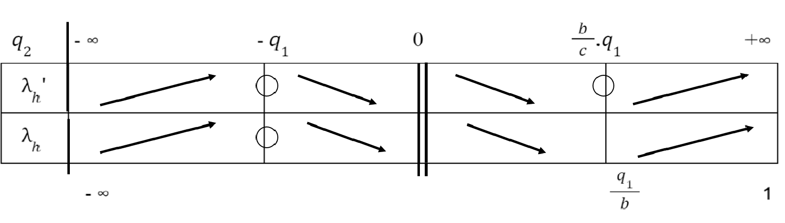
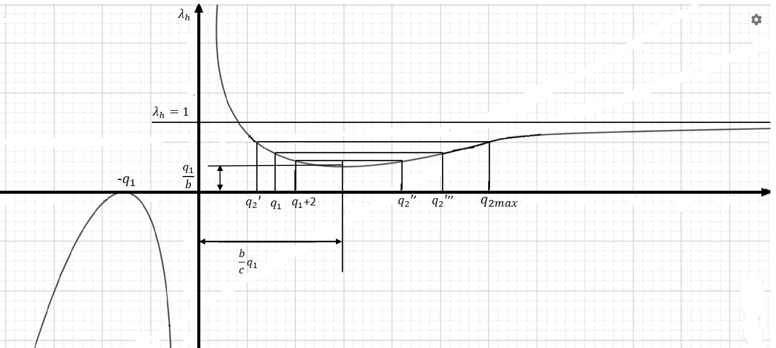

According to equation (7), there are two $q_{2}$ values for each $λ_{h}$ value. In prime numbers, the minimum value of the number that will come after $q_{1}$ is ${ q}_{1}+2$.

The corresponding root:${ q}_{2}''$
$λ_{c}=$ $\frac{q_{1}}{c}$ and $λ_{a}$ = $\sqrt{\frac{h}{a}}$ It is observed that the numbers are close to each other as seen in the LIST 1.

Before $\frac{q_{1}}{c}$ > $\sqrt{\frac{h}{a}}$ Suppose it is: (It is possible that it is small.)
$\frac{b-c}{c}$ > $\frac{\sqrt{a} -\sqrt{c}}{\sqrt{a}}$ $\frac{b}{c}-$1 > 1$-\sqrt{\frac{c}{a}}$ ve $\frac{b}{c}+\sqrt{\frac{c}{a}}$ > 2

If $\frac{q_{1}}{c}$ < $\sqrt{\frac{h}{a}}$ , $\frac{b}{c}+\sqrt{\frac{c}{a}}$ < 2 . As a result:
$\frac{b}{c}+\sqrt{\frac{c}{a}}$ ≅ 2 (8)

In real value:
m = $\frac{b}{c} +\sqrt{\frac{c}{a}}$ (9)

m, a value very close to 2; although usually 2 > m, for example
For the $p_{n}$= 1964987 value, m> 2 is. If you pay attention here, it is a very big difference like k = 90.
By examining the formula (7) and the graph, there are two values for $q_{2}$, to the left and right of the minimum peak. If one of them is a prime number, the other is not. If a is resolved from the formula (9):

a = c$(\frac{c}{mc-b})^{2}$ (10)

If m = 2 is written in this formula, the approximate value of a' is:

$a'$ = c$(\frac{c}{2c-b})^{2}$ (11) obtained.

The closest prime number to the prime number $q_{1}$ ($q_{1}$= $p_{n}$) mentioned in the previous pages is $q_{2}= q_{1}$ + 2
($q_{2}$=${ p}_{n+1}$) or $q_{2min}$ = $q_{1}$+ 2 therefore $a_{min}$= b + $q_{1}$ + 2

If there are prime or non-prime ${a'}_{min}$ (${or q'}_{2min}$) numbers, their corresponding
There are also numbers $a''$ (${or q''}_{2})$
If it is ${a'}_{min}$, it becomes $m_{max}$ according to the formula (9); If ${a''}_{max}$ is $m_{min }$.

As a result, both m values are very close to 2, one is greater than 2; the other is m numbers less than 2.

In this manner : $\frac{m_{min }+ m_{max}}{2}$ = 2 By accepting it, equation (12) can be written.

Since $m_{max}$ (${a'}_{min}$) is known with this equation, $m_{min }$(${a''}_{max}$) is found.

$m_{min }$= 4- $m_{max }$ (13)
The $m_{min}$ value of the other number to be found by making use of the mmax value, prime or non-prime, creates the value ${a''}_{max}$( ${veya q''}_{2max}$).

In this way:

${k"}_{2max}$ = ${q''}_{2max}$- $q_{1}$ We find the maximum value of k'' that can be greater than .

${a''}_{max}$ - b = ${q''}_{2max}$

${a'}_{min}$ - b = $q_{1}$+ 2 ${a''}_{max}$ - ${a'}_{min}$ = ${q''}_{2max}$ - $q_{1}$- 2

${q''}_{2max}$ - $q_{1}$ = ${a''}_{max}$ - ${a'}_{min}$ +2 ${a''}_{max}$ - ${a'}_{min}$ = $Δa'$

${k''}_{max} =Δa'+2$
${k''}_{max}$ returns the maximum possible difference between two consecutive prime numbers. If the prime number after $q_{1}$ is to be searched, that number is displayed as
${q''}_{2max}$ = $q_{1}$ + ${k''}_{max}$ as maximum.

List 1

 |  | h | lh = h / | l = / Σ | = | = = / c
101 | 103 | 8,970 842 516 | 0,087 095 5584 | 0,0869939707 | 0,084244795298 | 0,095283018867
1823 | 1831 | 14,213 482 476 949 | 0,007 762 688 409 | 0,007 762 665 962 | 0,007749539412 | 0,007 823 396 375
5309 | 5323 | 16,949 523 704 | 0,0 003 071 486 699 | 0,003 0714 86549 | 0,003070808986 | 0,003080949645
6547 | 6551 | 16,735813217 | 0,002 554695 957 | 0,002 554 693542 | 0,002 597 689 358 | 0,002561236717
8669 | 8677 | 17,337509495467 | 0,001998099515 | 0,001998098936 | 0,001997024994 | 0,002002099329
9551 | 9587 | 17,3205080964 | 0,001806666131 | 0,001806664399 | 0,00180842790788 | 0,001809934343215
24077 | 24083 | 19,108385861779 | 0,0007934387684 | 0,0007934387097 | 0,000793222892382 | 0,0007940068755
75853 | 75869 | 21,470776519637 | 0,000 282 998 016 | 0,0002829980162 | 0,000282987 812 458 | 0,000288078126756
381103 | 381167 | 24,698051702453 | 0,0000647958813 | 0,0000647958811 | 0,000064799220674 | 0,000064800079
514967 | 515041 | 25,283298430568 | 0,000049089875234 | 0,000049089875124 | 0,000049092188788 | 0,000049092285058
999979 | 999 983 | 26,647880909792 | 0,000026648333931 | 0,000026648333928 | 0,000026648020564 | 0,000026649044081

Example 1:

$q_{1}$= $p_{n}$= 9551 | - b = b = Σ$p_{n}$ = 5286538 | - c = c = Σ$p_{n-1}$= 5276987

${q'}_{2min}$ = $q_{1}$+ 2 | ${q'}_{2min}=$ 9553
$a_{min}$= b + $q_{2min}$ = b + $q_{1}$ + 2 | $a_{min}$= 5296091
$m_{max }$= $\frac{b}{c}$ + $\sqrt{\frac{c}{a_{min}}}$ | $m_{max}$ = 2,000004710539
$m_{min }$= 4- $m_{max }$ | ${ m}_{min }$ = 1,999995289460
$a_{max} = c (\frac{c}{c.m_{min}-b})^{2}$ | $a_{max}$ = 5296191
$Δa =$ $a_{max}$ - $a_{min}$ | $Δa$ = 100
$k_{max} =Δa+2$ | $k_{max}$= 102
${q''}_{2max}$= ${ q}_{1}$ + $k_{max}$ | ${q''}_{2max}$= 9653

Real prime number: $q_{2}$ = $p_{n+1}$ = 9587. And 9587 < 9653.

Example 2:

$q_{1}$= $p_{n}$= 197971 | b = Σ$p_{n}$ = 1677164856 | c = Σ$p_{n-1}$= 1676966885

${ q'}_{2min}=$ $q_{1}$+ 2 | ${q'}_{2min}$ = 197973
$a_{min}$= b + $q_{2min}$ = b + $q_{1}$ + 2 | $a_{min}$= 1677362829
$m_{max }$= $\frac{b}{c}$ + $\sqrt{\frac{c}{a_{min}}}$ | $m_{max}$ = 2,000 000 020 304 555
$m_{min }$= 4- $m_{max }$ | $m_{min }$ = 1,999 999 979 695 445
$$a_{max} = c (\frac{c}{{c.m}_{min}-b})^{2}$$ | $a_{max}$ = 1,677 362 965
$Δa =$ $a_{max}$ - $a_{min}$ | $Δa$ = 136
$k_{max}= Δa+2$ | $k_{max}$= 138
${q''}_{2max}$= ${ q}_{1}$ + $k_{max}$ | ${q''}_{2max}$= 198109

Real prime number: $q_{2}$ = $p_{n+1}$ = 198013. And 198013 < 198109.

Example 3:

$q_{1}$= $p_{n}$= 14867 | b = Σ$p_{n}$ = 12098389 | c = Σ$p_{n-1}$= 12113258

${ q'}_{2min}=$ $q_{1}$+ 2 | ${q'}_{2min}$ = 14869
$a_{min}$= b + $q_{2min}$ = b + $q_{1}$ + 2 | $a_{min}$= 12113258
$m_{max }$= $\frac{b}{c}$ + $\sqrt{\frac{c}{a_{min}}}$ | $m_{max}$ = 2,000 00218355454
$m_{min }$= 4- $m_{max }$ | $m_{min }$ = 1,999 99781644546
$$a_{max} = c (\frac{c}{{c.m}_{min}-b})^{2}$$ | $a_{max}$ = 12113364
$Δa =$ $a_{max}$ - $a_{min}$ | $Δa$ = 106
$k_{max}= Δa+2$ | $k_{max}$= 108
${q''}_{2max}$= ${ q}_{1}$ + $k_{max}$ | ${q''}_{2max}$= 14975

Real prime number: $q_{2}$ = $p_{n+1}$ = 14869. 14869 < 14975.

All my friends who have the opportunity to check all these studies for large prime numbers; I ask them to inform me both the results and the parts they find missing.
Kind regards

Murat BUDA

